Connect to Git Hub and Create MTA Application

The main purpose of this document is to show how to setup GitHub repository for creating a MTA application using Git Hub repository.

1. Log in or create an account in Git Hub. Create a new repository:

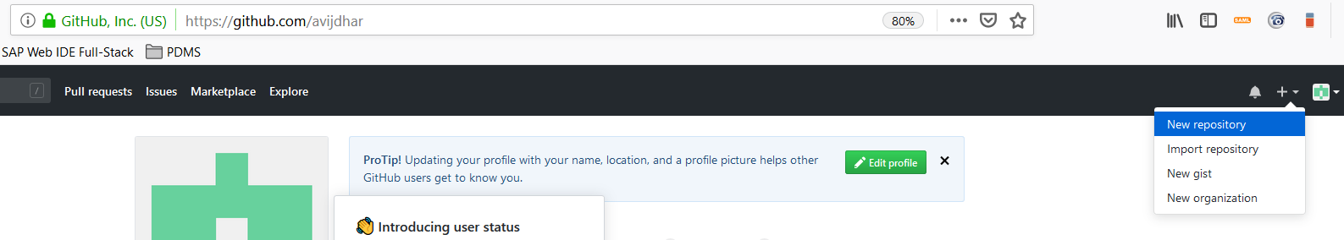

1. You can choose any name you want and click on **Create Repository**:

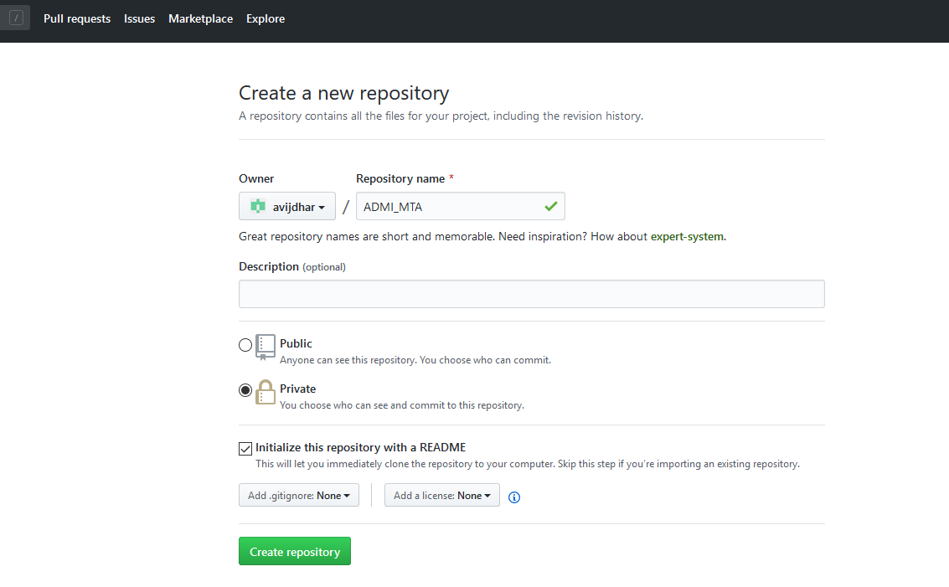

1. Once created, click on the **Clone or download** and **copy the URL** so you have it handy. Keep this tab **open**.
2. Add a blank mta.yaml file in the repository.
3. Click on “Clone or download” button and copy the url as shown below.

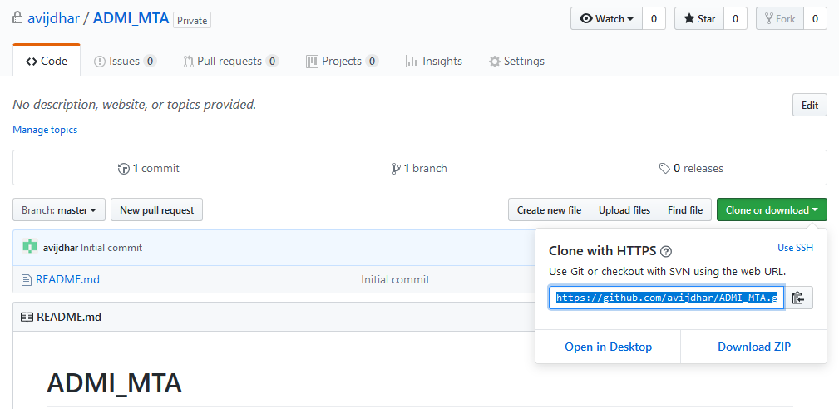

1. Once the Web IDE has loaded, you will clone your GitHub repository. Right-click on the Workspace and then on Git->Clone Repository.

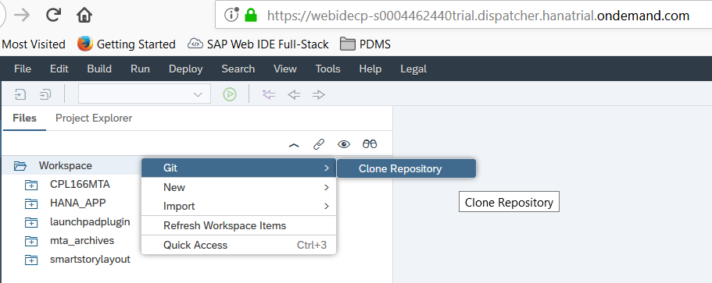

1. Then paste the URL from your Git Hub repository as shown below.

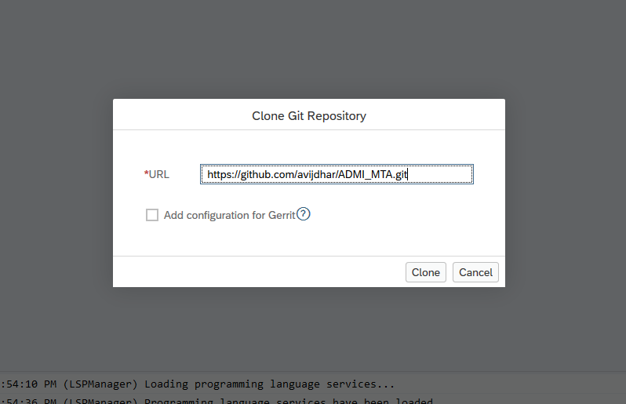

1. Enter GitHub username and password if prompted and you should see a message as shown below once the clone is completed.

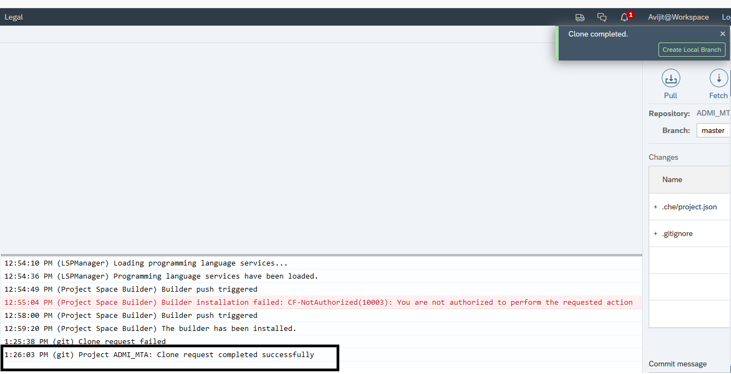

1. You should see a single project in your workspace.

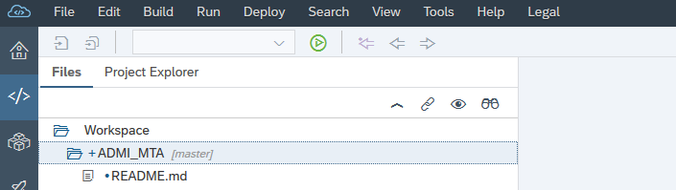

1. Right-click on the project and then on **Project Settings**:

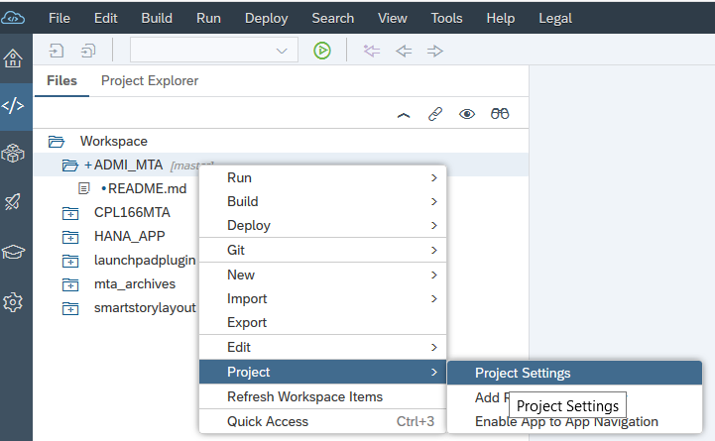

1. Go into the Git Repository click on **Save**.

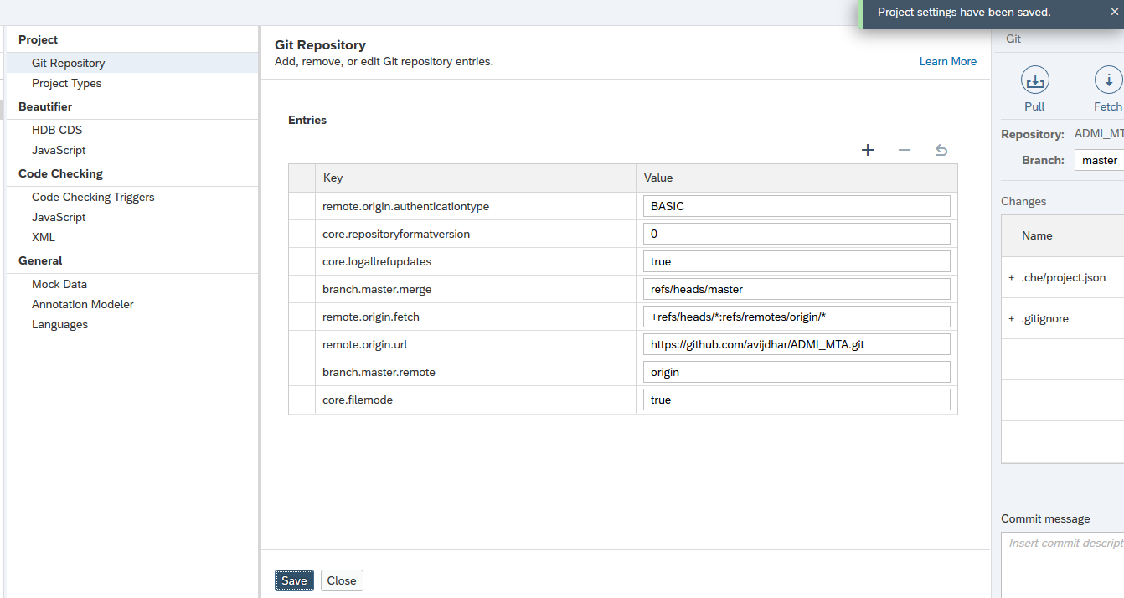

1. Add the following changes in the mta.yaml file.

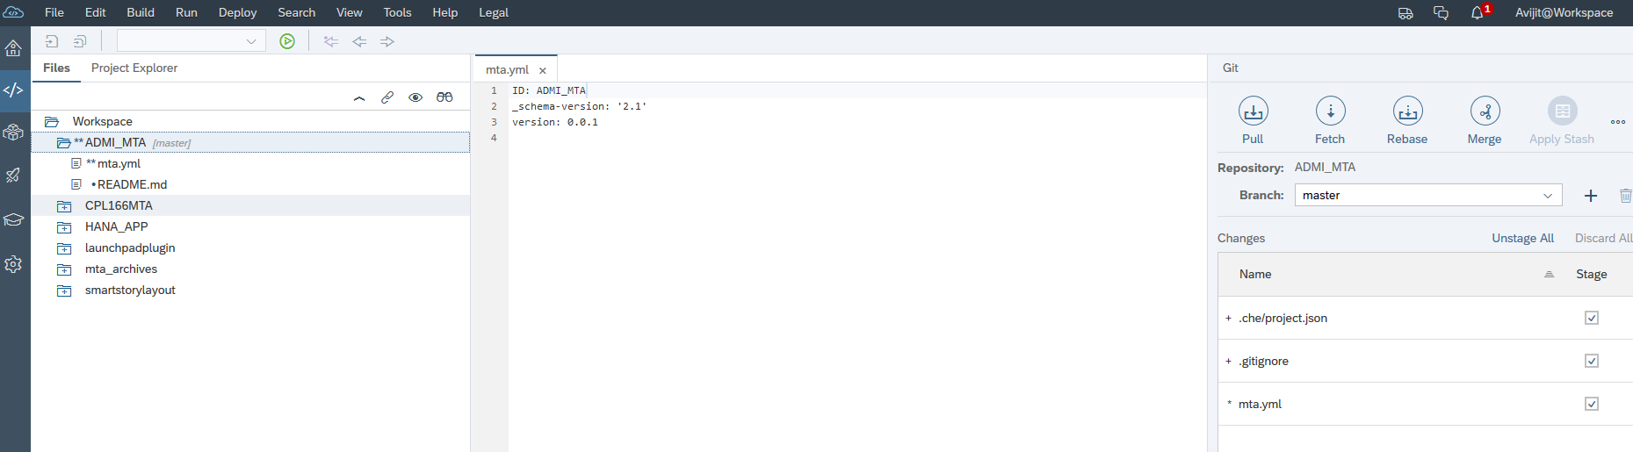

1. Go to Git Pane by clicking the  icon and click on Stage All as shown below.

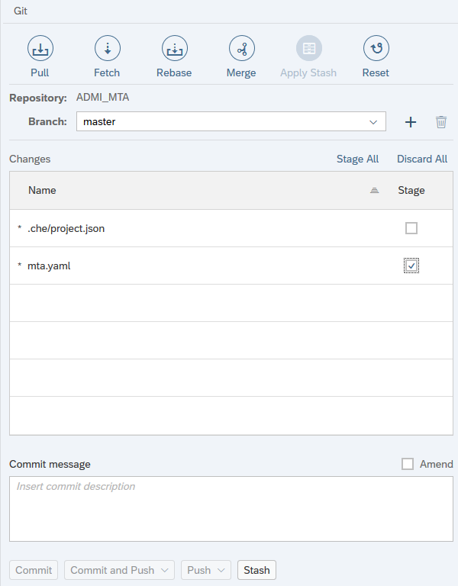

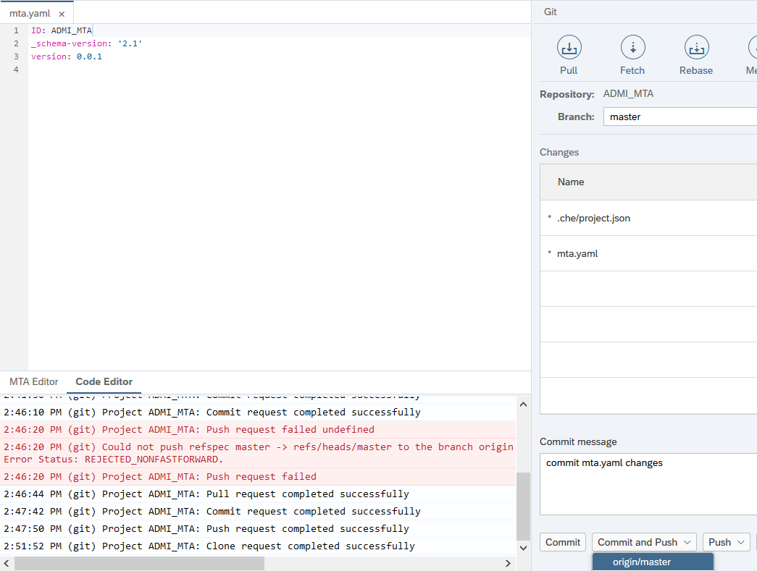

1. Enter a comment for the initial commit and click on **Commit and Push**

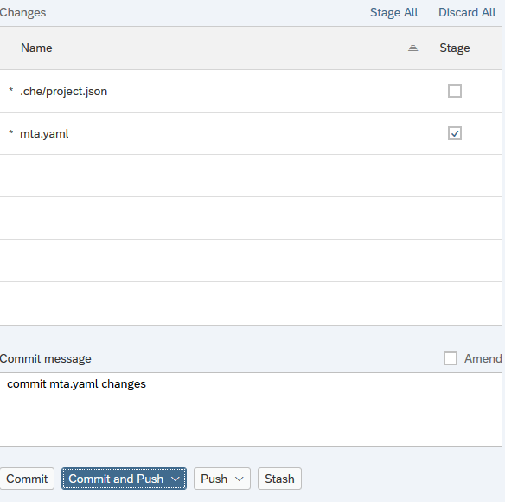

1. You will be prompted for your GitHub account details

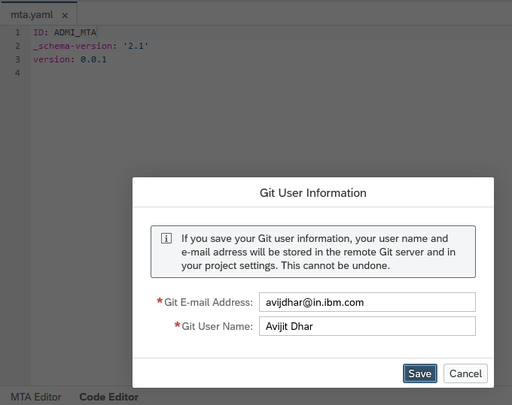

1. Once completed you will get the following successful message.



1. You can validate the committed changes by opening the file from your git repository.

